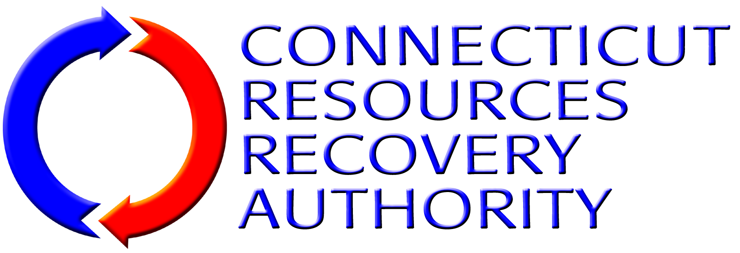

ADDENDUM NO. 1

Issued October 5, 2010

TO

“REQUEST FOR QUALIFICATIONS

FOR

MID-CONNECTICUT RESOURCE RECOVERY FACILITY AND JET TURBINE FACILITY POWER PURCHASE

(RFQ Number 12-OP-002)

(RFQ Issued September 12, 2011)
Note: Entities submitting a Statement Of Qualifications are required to acknowledge this and all Addenda in Section 4 of the Statement Of Qualifications Form.
This Addendum consists of the Connecticut Resources Recovery Authority’s (CRRA) responses to written questions received as of October 5, 2011.
 | Question | Please provide CRRA’s financial statements.
 | Answer | CRRA’s audited financial statements, Comprehensive Annual Financial Reports, annual budgets, operating reports and a host of other reports addressing CRRA’s finances and budgeting are posted on CRRA’s web site at www.crra.org. Click on “Public Records” listed in the menu provided on the right hand side of the web site’s home page.
 | Question | What is the due date for comments to the power purchase agreement for the CRRA RFQ?
 | Answer | If a Statement of Qualifications (SOQ) submitter wishes to provide comments, take exception to, or modify any of the provisions contained in the form of the agreements contained in the RFQ package of documents (Attachment 1 and Attachment 2 to the RFQ package of documents), submitter shall complete and submit the Business Exception Form (Exhibit 9 to the RFQ package of documents) as part of its SOQ submittal. The deadline for the submittal of SOQs is 3:00 PM EST, Friday, October 21, 2011.
- END OF ADDENDUM 1 -

